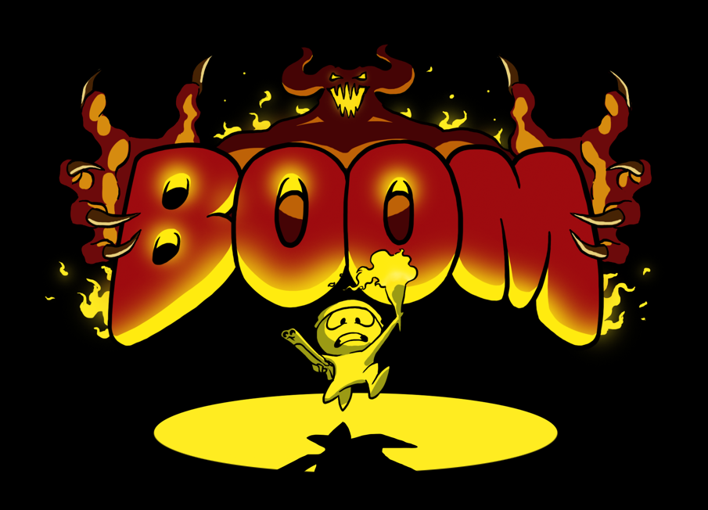

DESIGN DOCUMENT

Table of Contents

Introduction 4

High Concept 4

Summarium (Summary) 4

Core aspects of Gameplay: 4

Game Style and Setting 5

Feature Sets 5

Gameplay 5

First Minute 5

Game-flow 6

Victory Condition 6

Score keeping 6

Graphics and Art Style 7

Character style 7

Colour Palette 7

Background and Environment 8

Game HUD (TODO ADD IMAGE) 8

Sound 8

Music 9

Controls (TODO – ADD IMAGE) 9

For PC 9

For Mobile 10

Timer and Chasing (TODO) 10

Satan’s Chase Timer (TODO) 10

Monsters 10

Horny the Imp 11

Spot the Hell-pup 11

Rosy the Demon 11

Traps 11

Power-Ups 11

Speed 12

Shotgun 12

Level Design (toDO) 12

Plot 13

Cinematics 13

Optional (Nice to Have’s) (TODO) 14

LEVEL EDITOR (TODO) 14

Additional Monsters (TODO) 14

Additional Traps (TODO) 15

Additional Power-Ups (TODO) 15

Additional Cinematics (TODO) 15

# ../Documents/UL/Year%201%20-%20Semester%202/CS4043%20-%20Games%20Modelling%20Design/Assignments/Game/Art/VerticalCorridorConcept.pnIntroduction

## High Concept

BOOM is an isometric dungeon runner through the bowels of hell where the player has to avoid traps and shoot monsters while being chased by Satan.

The Core of the game is Speed. The core loop runs as follows:

1. Shoot monsters
2. Collect Power-ups from dead monsters to move faster
3. Get to the next checkpoint without being caught by Satan

## Summarium (Summary)

### Core aspects of Gameplay:

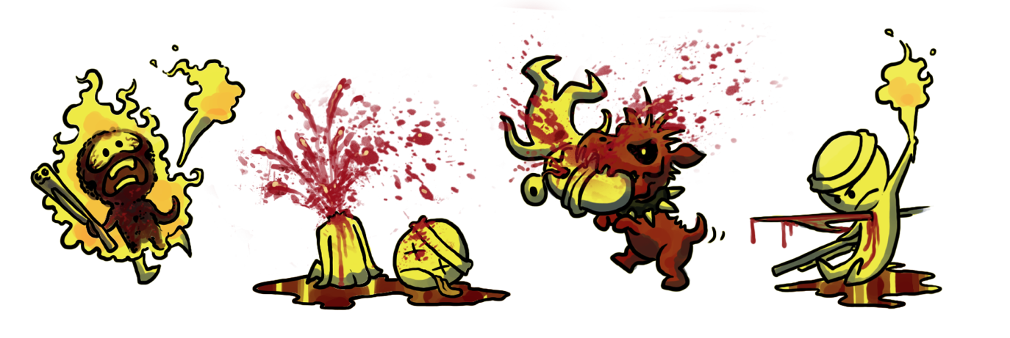

BOOM is an isometric dungeon runner game of Speed and Punishment.

The player’s goal is to get to the end as fast as possible without dying. Ahead are various monsters and traps. Satan’s on your heel and gaining on you, and there is no time to stop and figure out how a trap works or how a monster behaves. instead you’ll have to learn by trial and error.

The player is given a shotgun and can use it to kill monsters at close range. On killing monsters, power-ups will be dropped to increase your speed or increase the range and damage of your shotgun.

Each lap is recorded from the time it takes to run between checkpoints without dying. The lap timer is reset on dying and the final run time is determined by combining the total lap times of all the levels run. This time is submitted to the leaderboard along with the number of deaths stacked up during the run.

### Game Style and Setting

You play an accountant who signed up for a charity run and somehow ended up in hell. Now you’re desperately running to escape.

BOOM combines cute and cartoony with graphic and violent. Killing monsters utilizes the Corona physics engine for monster guts exploding. Torture devices and corpses line the walls and corridors. Boom is what toon nightmares are made of.

## Feature Sets

* Corona’s powerful Physics Engine utilized for sending monster guts flying on shotgun impact.
* Particle system used to enhance hell’s fiery aesthetic.
* Satan chasing player to keep the game moving.
* Monsters and traps ahead of player as obstacles to dodge or shoot.
* Close range shotgun for removing monsters.
* Art style combining intense gore and cute cartoon characters

# Gameplay

## First Minute

On opening the game, the intro cinematic (see cinematics) will play, leading in to the title screen. On clicking “Play” the game will begin, starting with the camera on Satan walking toward Bob for 2 seconds and then panning over to Bob over 2 more seconds. The word “RUN” will flash on screen for one second with a voiceover of Satan saying “Run Mortal” and the HUD will appear, showing your speed, shotgun power, and how close Satan is to you. The player will then have control of Bob and begin running.

The player will first encounter a corridor of static fire traps, allowing them a moment to get a hang of the movement controls while they weave between the flames.

Once the player is passed the static fire traps, they will encounter a corridor of imps (one at a time, we’re not that cruel) throwing fireballs. This gives them a chance to get the hang of the aim and shoot controls while still dodging with the movement controls.

These two corridors act as a tutorial for the game, giving the player a chance to get the hang of controls while not letting it seem too easy or feel like hand holding. After these two corridors traps and enemies will mix, new enemies and new traps will show up, and the player will have to keep up with the game.

## Game-flow

Main Menu

## Victory Condition

The victory condition is based on completion of all levels. Your score is ranked from the combined time it takes to complete all checkpoints of all the levels within a run.

### Score keeping

The score keeping will be based on the combined time it takes to complete all levels in a run.

Your position on the leaderboard will be determined by the how fast you can complete the levels. Each time you die your speed and shotgun power will be reset to default, making it harder to get a fast time if you die between checkpoints. Each level will be given a default set of three times (Bronze, Silver, and Gold) based on the length of the level and amount of monsters. If you manage to score in the top 10, you will be asked to type in your name and the following stats will be displayed on the leaderboard:

* Medal (Gold, Silver or Bronze)
* Name
* Time
* Kills
* Deaths

Before the game has been played for the first time all leaderboards for each level will have a best score belonging to Gary (see cinematics to get the joke).

## Graphics and Art Style

### Character style

The art style for the characters will have the following features:

* Rounded, clean lines.
* Big heads, little bodies.
* All characters (except Satan) “cute”, including the monsters.
* Slight “wiggle” to animation, taking out perfect precision to capture a hand-made feel.
* Detailed gore for character deaths.
  + Blood splatter.
  + Physics throws body parts on monster deaths
    - Eyeballs
    - Skull fragments
    - Horns
    - Intestines

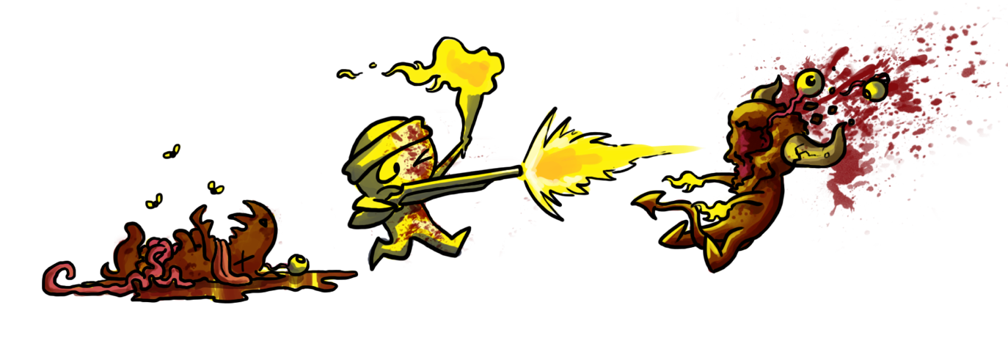

### Colour Palette

* 3 primary colours: Fire, Blood and Darkness (Colours of the German flag, just a coincidence? Or is it? I always knew those bastards were evil. World War 2 gave me an inkling, but their flag colour scheme is what really gave it away.)
* 2 tones for each color. Either highlight or shadow, never both. The exception will be during special effects such as the shotgun blast casting light.

### Background and Environment

The art direction for the backgrounds will be more detailed and will allow more colour variation while primarily staying within the 3 colour palette. Environment details will feature:

* Torture devices
* Demonic statues
* Satanic symbolism

## Game HUD

The HUD will be clean and minimalistic. There will be no graphical overlays. The following elements will be strategically placed.

* Speed Indicator
* Satan Indicator
* Shotgun Power bar
* On-Screen thumb-sticks (mobile only)
* Pause Button/Menu button

## Sound

The game’s sounds will be handled by corona’s built-in sound engine.

We will need to write our own function for directional audio by using two channels of the same audio file, lowering one and increasing the other to provide a directional effect as corona doesn’t have panning built in. This will be used for Satan’s chase voice FX and fireballs flying past the player.

Character sounds:

* Shotgun blast
* Footsteps
* Panting
* Torch sounds
* Death sounds

Enemy sounds:

* Satan
  + Maniacal evil laughter(directional)
  + Voice FX(directional)
* Horny the imp
  + Fireball sounds(directional)
  + Laughing sounds(directional)
  + Death sounds(directional)
* Rosy the Demon
  + Axe swing(directional)
  + Puffing(directional)
  + Death sounds(directional)
* Spot the hell pup
  + Excited puppy noises(directional)
  + Transformation sound
  + Death sounds(directional)

Environmental sounds:

* Fire
* Traps
* Pick-ups
* Ambient hell sounds

## Music

Being based around hell and speed, the game will feature fast metal music to immerse the player in the high-speed blood-fest that will keep the player running.

* Title: Boom’s theme tune
* Cinematics: variety of comic tunes and intro to theme tune
* In game: Fast metal music

## Controls (TODO – ADD IMAGE)

### For PC

Thumb-sticks to move and aim, right trigger to shoot. Start button to pause the game and take you to the pause menu.

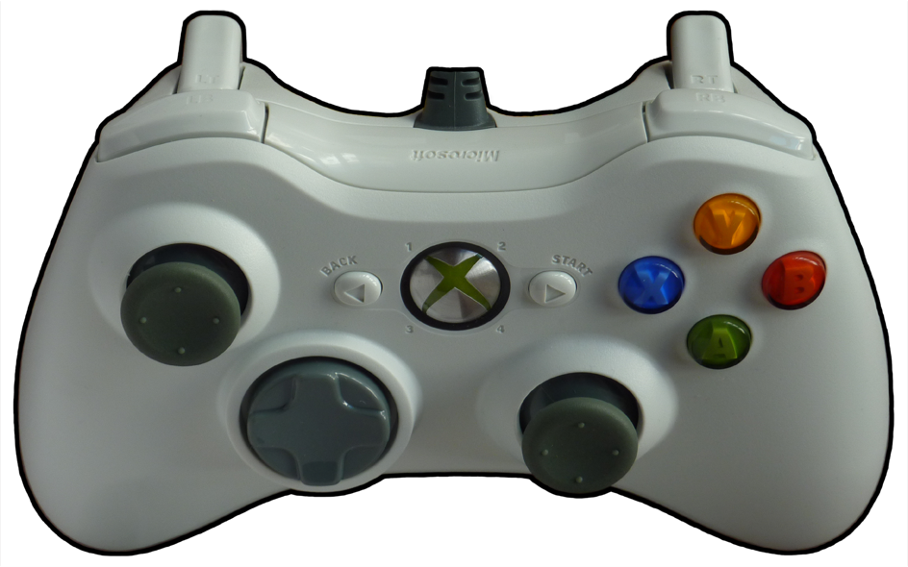

### For Mobile

Virtual thumb-sticks to move and aim, when the right thumb-stick (aim) is pulled past its boundary, the player will shoot. Pause button in the top corner to pause the game and take you to the pause menu

## 

## Timer and Chasing

Time and speed is the core of the game.

### Satan’s Chase Timer

Satan, like the player, will start off moving slowly.

## Monsters

Monsters will be inactively placed around the map at the start of the level. Once the player’s screen comes within 10 pixels, the monster will be activated and will start attacking the player. If a monster’s attack lands the character is instantly killed switching to the death screen for that monster.

### ../Graphics/Art/Minator.png../Graphics/Art/Imp.pngHorny the Imp

Horny the imp is a small impish creature that will stand still and throw balls of fire in a straight line at the player. The speed and frequency of the fireball blasts will be based on the current game time, growing faster as the game progresses. Horny will take one shotgun blast to kill. The fireball will be destroyed upon hitting a wall.

### ../Graphics/Art/HellPup.pngSpot the Hell-pup

Spot the hell pup will excitedly run in a straight line towards the player. When Spot enters the torchlight of the player it will transform into a hell hound and maul the player. Spot will take one shotgun blast to kill and will appear on the ground as a sad dead puppy with its intestines pouring out of its twitching body.

### Rosy the Demon

Rosy the demon is a minotaur is the slowest monster and can take the most damage. Rosy will take 3 shotgun blasts to kill. Upon activation Rosy will slowly walk towards the player shielding herself with her axe. Once within 2 character lengths she will begin swinging her axe in a deadly arc. On pulling her axe back for a swing the player has the opportunity to kill Rosy as she is exposed.

## Traps

Traps will be placed around each level for the player to avoid, touching traps will cause a variety of effects as explained below.

#### Static Fire Trap

A patch of fire on the ground the size of the character. This trap will instantly kill the player if touched but does not change making it relatively easy to dodge.

#### Slow Traps

When walked over these stationary traps will slow you down by 70% when you walk over them. Once out of the trap your speed returns to normal.

#### Moving Traps

These traps will move back and forth and will instantly kill the player, must use careful timing to avoid. (swinging axes, retracting spikes, etc.)

## Power-Ups

Drop rate of power-ups: Every monster killed has a chance to drop either a…

1. Speed Power-up 45% chance
2. Shotgun Power-up 25% chance
3. Nothing 30% chance

When colliding with a power-up the power-up is consumed/collected/gone.

### Speed

Max velocity starts at 10 pixels per tick. When collecting a speed power-up, your velocity is permanently increased by 1. There is no upper bound to how many power-ups you may collect. In the HUD your speedometer begins at 1 and is updated at a count of 1 with each power-up collected.

### Shotgun

Initial length of shotgun blast is the length of the character height. When collecting a shotgun power-up, your blast length is increased by 10% of the original size. In the HUD your Shotgun-o-meter begins at 1 and is updated at a count of 1 with each power-up collected. The max number of shotgun power-ups you can collect is 20.

## Level Design (toDO)

Now let’s pretend we have a typical 2D platformer. One of the core elements of the game is the stages the player has to go through. It’s important that each stage feels unique so the player won’t feel like he’s just repeating the same thing over and over again. On the other hand, the player should still be familiar with the flow of the stage, i.e. if there’s always a checkpoint somewhere halfway through it, or some collectible items along the way.

What are the different types of enemies, terrains, doodads and power ups and do they allow the level designers to come with many different stages? You could present some beta stage diagrams to illustrate how will they be carried out.

Example:

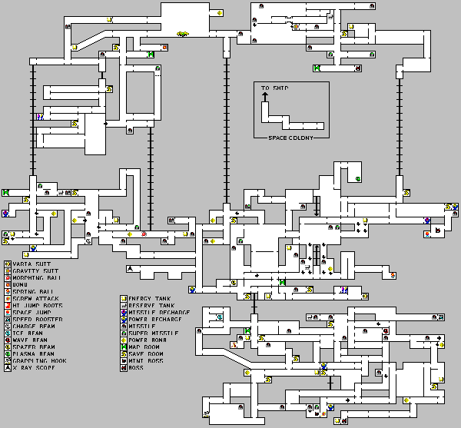

## Plot

You’re no marine. You’re Bob, an accountant, who happened to sign up for a local charity run. You thought you’d take a shortcut but ended up in the bowels of hell. Now, armed with a holy shotgun, you have to fight your way through to the other side and make it in time for at least 3rd place prize: a toaster!

## Cinematics

Cinematics to the game will be shown in slides with bits of animation thrown in

Introduction Cinematic (launching the game):

1. “Cure for athletes’ foot Charity Run.” banner establishing shot
   1. Show prizes.
2. Bob running, arrow pointing to him: “Bob, the accountant”
3. Gary running, arrow pointing to him: “Gary, five-time winner employee of the month at bob’s accounting firm, Bob’s arch-nemesis.”
4. Gary: “Don’t get lost, Bob”
5. Bob thought bubble: “Fuck you Gary. Pfft, get lost… I’ll show you get lost.”
6. “5 minutes later”
7. Bob in the bowels of hell: “I think I might be lost”
8. Satan: “Bob, for your sins of being a really boring accountant, your soul is now MINE!”
9. Bob running: aaaaahhhhhhh! Satan laughing: nyhahahahahahaha
10. Bob sees monsters ahead
11. Bob falls to his knees: “God help me!” Light shines, shotgun drops from above.
12. Note on shotgun: “Here have this, would help but I’m kind of busy.”
13. Bob begins running, turns into BOOM logo and menu.

Ending Cinematic:

1. Yes! I’ve escaped, and there’s the finish line!
2. Bob runs past the finish line.
3. Announcer: “Well done Bob, you’ve won…”
4. “… (Bronze/Silver/Gold)!” (Gary in first place if you don’t win first place)
5. (If not first place:) Gary: “So what happened, slow poke? Got lost?” Bob: “Fuck you Gary.”
6. (If in first place:) Gary: “Well done Bob!” Bob: “Fuck you Gary.”

## Optional (Nice to Have’s) (TODO)

"Lorem ipsum dolor sit amet, consectetur adipiscing elit, sed do eiusmod tempor incididunt ut labore et dolore magna aliqua. Ut enim ad minim veniam, quis nostrud exercitation ullamco laboris nisi ut aliquip ex ea commodo consequat. Duis aute irure dolor in reprehenderit in voluptate velit esse cillum dolore eu fugiat nulla pariatur. Excepteur sint occaecat cupidatat non proident, sunt in culpa qui officia deserunt mollit anim id est laborum."

### Level Editor (TODO)

"Lorem ipsum dolor sit amet, consectetur adipiscing elit, sed do eiusmod tempor incididunt ut labore et dolore magna aliqua. Ut enim ad minim veniam, quis nostrud exercitation ullamco laboris nisi ut aliquip ex ea commodo consequat. Duis aute irure dolor in reprehenderit in voluptate velit esse cillum dolore eu fugiat nulla pariatur. Excepteur sint occaecat cupidatat non proident, sunt in culpa qui officia deserunt mollit anim id est laborum."

### Additional Monsters (TODO)

"Lorem ipsum dolor sit amet, consectetur adipiscing elit, sed do eiusmod tempor incididunt ut labore et dolore magna aliqua. Ut enim ad minim veniam, quis nostrud exercitation ullamco laboris nisi ut aliquip ex ea commodo consequat. Duis aute irure dolor in reprehenderit in voluptate velit esse cillum dolore eu fugiat nulla pariatur. Excepteur sint occaecat cupidatat non proident, sunt in culpa qui officia deserunt mollit anim id est laborum."

### Additional Traps (TODO)

"Lorem ipsum dolor sit amet, consectetur adipiscing elit, sed do eiusmod tempor incididunt ut labore et dolore magna aliqua. Ut enim ad minim veniam, quis nostrud exercitation ullamco laboris nisi ut aliquip ex ea commodo consequat. Duis aute irure dolor in reprehenderit in voluptate velit esse cillum dolore eu fugiat nulla pariatur. Excepteur sint occaecat cupidatat non proident, sunt in culpa qui officia deserunt mollit anim id est laborum."

### Additional Power-Ups (TODO)

"Lorem ipsum dolor sit amet, consectetur adipiscing elit, sed do eiusmod tempor incididunt ut labore et dolore magna aliqua. Ut enim ad minim veniam, quis nostrud exercitation ullamco laboris nisi ut aliquip ex ea commodo consequat. Duis aute irure dolor in reprehenderit in voluptate velit esse cillum dolore eu fugiat nulla pariatur. Excepteur sint occaecat cupidatat non proident, sunt in culpa qui officia deserunt mollit anim id est laborum."

### Additional Cinematics (TODO)

"Lorem ipsum dolor sit amet, consectetur adipiscing elit, sed do eiusmod tempor incididunt ut labore et dolore magna aliqua. Ut enim ad minim veniam, quis nostrud exercitation ullamco laboris nisi ut aliquip ex ea commodo consequat. Duis aute irure dolor in reprehenderit in voluptate velit esse cillum dolore eu fugiat nulla pariatur. Excepteur sint occaecat cupidatat non proident, sunt in culpa qui officia deserunt mollit anim id est laborum."